1. What’s the Order? (3.1.A)

3838 8259 3851 8731

Place the numbers in order from smallest to largest on the number line below.

2. How far is it from 132 to 700? (3.1.C)
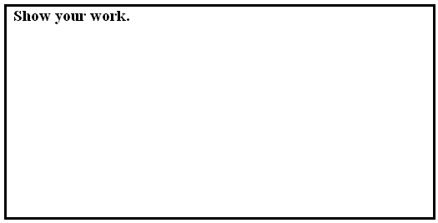

3. Round 3,235 to the nearest thousand. (3.1.B)

4. Round 6,789 to the nearest hundred. (3.1.B)

5. Round 5,432 to the nearest ten. (3.1.B)

6. Which number names the difference between 57 and 100? (3.1.C)

A. 43
B. 143
C. 157

7. About how many thousands are in the sum of 4,661 + 3,409? (3.1.D)

A. 4 thousands

B. 7 thousands

C. 8 thousands

8. About how many hundreds are in the sum of 286 + 550? (3.1.D)

A. 5 hundreds

B. 7 hundreds

C. 8 hundreds

Gina and Edwin both have collections of dried leaves.

Leaf Collection

Owner: Edwin
Number: 167 leaves
Details: Edwin and his family go camping every summer, and while they are in the woods, he spends time looking for new leaves to put in his collection.

Leaf Collection

Owner: Gina
Number: 96 leaves
Details: Gina’s favorite fall activity is to look for bright colored leaves to add to her collection.

9 a. How many more leaves does Edwin have in his collection than Gina? (3.1.E)
Show how you know. Be sure to write an equation to show what you did.

9 b. Gina and Edwin put all the leaves in their collection on the table in the Science Corner. They then decided to throw away 24 dead leaves. How many leaves are on the table? (3.1.E)
Show how you know. Be sure to write equations to show what you did.

10. Estimate the sum that is greater than 1000? (3.1.D)

A. 315 + 508

B. 155 + 711

C. 274 + 761

11. Estimate the difference that is less than 100? (3.1.D)

A. 336 - 183

B. 155 - 86

C. 145 - 3 9

12. Which number is equal to eight thousand three hundred seventy-eight? (3.1.A)

A. 8,378

B. 8,738

C. 8,783

13. Ms. Kim said, “Turn to page one hundred thirty-six.” What is the page number
written in standard form? (3.1.A)

A. 136

B. 163

C. 1,306

Donnie has these five cards.
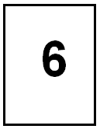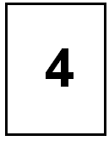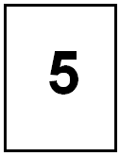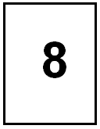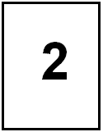

14 a. Use four of these cards to make the largest number you can. (3.1.A)

14 b. Use four of these cards to make the smallest number you can. (3.1.A)

15. Solve the following. Show your work. (3.1.C)
13 – 8 =

16. Solve the following. Show your work. (3.1.C)
48 + 64 =

17. Which sum is equal to 1000? (3.1.C)

A. 333 + 777

B. 408 + 592

C. 555 + 555

18. Solve the following. Show your work. (3.1.C)
5,267 + 4,205 =

- Ms. Winger had a box of 4000 craft sticks. Her 3rd-grade class used 482 sticks for a project. How many sticks are left? (3.1.E)

20. Sophia had $454 in the bank. Then she earned $157. Then Sophia spent $24 on a
softball. How much money does she have left? (3.1.E)

A. $613

B. $587

C. $635

21. Which is the best estimate for 732 + 419? (3.1.D)

A. between 1,000 and 1,100

B. between 1,100 and 1,200

C. between 1,200 and 1,300

